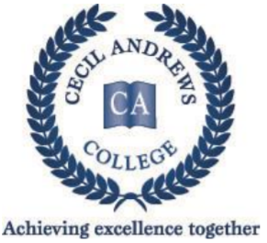
YEAR 11 ATAR CHEMISTRY

Units 1 & 2 TASK 5

Practical Report 1 Quiz ANSWERS MARKS: 30

EXPERIMENT 13: BONDING AND ELECTRICAL Conductivity

1. Write the name or formula in the correct place in the table of all 12 substances tested
in the experiment. (6 marks)
( ½ mark each answer)

 | Pure Substance |  | Solution
 | Strong Electrolyte | Non Electrolyte | Strong Electrolyte | Non Electrolyte
Ionic Bond | NaOH(s)or(l)  AgNO₃(s)or(l) |  | NaCl(aq)  NaOH(aq)
Covalent Bond |  | Candle wax  Naphthalene  S₈  Ethanol  H₂O | HCl(aq) | Sucrose(aq)  Kerosene

2. Complete the equations (including states) to show the final product(s) when the following dissolve in water. (2 marks)
(- ½ no states shown)
a) NaCl_{(s)} → Na⁺(aq) + Cl⁻(aq)

b) C₁₂H₂₂O_{11(s)} → C₁₂H₂₂O₁₁(aq)

EXPERIMENT 1.1 : FLAME TESTS

3. Write the colour of the cation flame in the space provided (2 marks)
Cation | Colour
Potassium | violet / pink/purple/lilac
Calcium | orange
Strontium | red
Sodium | yellow/intense yellow

4. Explain what happens to the electrons when they are heated. (1 mark)

The electrons in the metal ion gain energy and can jump into a higher energy level.

5. Why do the substances produce light of distinct colours? (3 marks)
(1 mark)
When excited electrons fall back to where they were before, they release energy in the
form of light. This energy corresponds to particular wavelengths of light, and so
produces particular colors of light. (1 mark) (1 mark)

Experiment 44 : MOLECULAR MODELS OF ORGANIC COMPOUNDS

6. Write structural formula and names for all isomers of C₆H₁₄. (5 marks)
( ½ mark each answer)

STRUCTURAL FORMULA | NAME
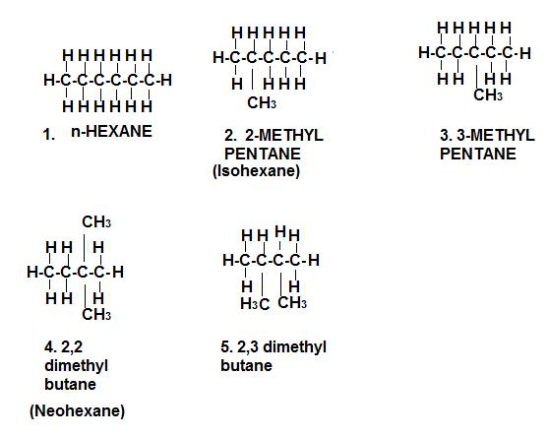 | Hexane  2 – methylpentane  3 – methylpentane  2,2 – dimethylbutane  2,3 – dimethylbutane

(must have structure correct to get marks for names)

7. Write structural formulas and names for all isomers of C₂H₂Cl₂. (3 marks)
( ½ mark each answer)

STRUCTURAL FORMULA | NAME
H Cl  | |  H – C = C – Cl  Cl Cl  | |  H – C = C – H  Cl H  | |  H – C = C – Cl | 1,1 - dichloroethene  cis – 1,2 - dichloroethene  trans –1, 2 - dichloroethene

(must have structure correct to get marks for names and names must include numbers)

INVESTIGATION 46 : REACTIVITY OF HYDROCARBONS

8. What is Bromine water? (1 mark)

Bromine liquid dissolved in water

9. When bromine water is shaken with cyclohexane, and the mixture is allowed to settle,

- What is the solvent of the upper layer? (1 mark)

Organic (cyclohexane)

- What is the solvent of the lower layer? (1 mark)

Aqueous (water)

- Explain what has happened to the bromine
(with the use of an equation if this is appropriate) (2 marks)

one bromine has substituted onto the cyclohexane ring
OR
insufficient light (time) for substitution reaction to occur (1 mark)
Br

+ Br₂ ➔        + HBr

C₆H₁₂ + Br₂ ➔ C₆H₁₁Br + HBr (1 mark)

10. When bromine water is shaken vigorously with cylcohexene, and the mixture
is allowed to settle,

a) What is observed? (1 mark)

The solution turns colourless

b) Explain what has happened to the bromine
(with the use of an equation if this is appropriate) (2 mark)

double bond breaks and both bromine attach to the ring (1 mark)

Br
+ Br₂ ➔

Br
C₆H₁₀ + Br₂ ➔ C₆H₁₀Br₂ (1 mark)

END OF TEST

